## Business Intelligence

Unit I

Introduction

• The business environment is constantly changing and is becoming complex day by day.

• Organizations are now becoming agile to sudden changes hence now making frequent and quick strategic, tactical, operational decisions.

• Making such decisions require considerable amount of relevant data, information and knowledge.

• Decisions needs to be done in real time now.

Brief History of BI

• The term BI was coined by the Gartner Group in the mid-1990s.

• However, the concept is much older; it has its roots in the MIS reporting systems of the 1970s. During that period, reporting systems were static, two dimensional, and had no analytical capabilities.

• In the early 1980s, the concept of executive information systems (EIS) emerged. This concept expanded the computerized support to top-level managers and executives. Some of the capabilities introduced were dynamic multidimensional (ad hoc or on-demand) reporting, forecasting and prediction, trend analysis, drill-down to details, status access, and critical success factors.

• These features appeared in dozens of commercial products until the mid- 1990s. Then the same capabilities and some new ones appeared under the name BI.

• Today, a good BI-based enterprise information system contains all the information executives need. So, the original concept of EIS was transformed into BI.

• By 2005, BI systems started to include artificial intelligence capabilities as well as powerful analytical capabilities.

History of business intelligence

The term business intelligence was first used in 1865 by author Richard Millar Devens, when he cited a banker who collected intelligence on the market ahead of his competitors. In 1958, an IBM computer scientist named Hans Peter Luhn explored the potential of using technology to gather business intelligence. His research helped establish methods for creating some of IBM’s early analytics platforms.

In the 1960s and 70s, the first data management systems and decision support systems (DSS) were developed to store and organize growing volumes of data.

“Many historians suggest the modern version of business intelligence evolved from the DSS database,” says the IT education site Dataversity. “An assortment of tools was developed during this time, with the goal of accessing and organizing data in simpler ways. OLAP, executive information systems and data warehouses were some of the tools developed to work with DSS. [2](https://www.ibm.com/topics/business-intelligence#citation2)

By the 1990s, business intelligence grew increasingly popular, but the technology was still complex. It usually required IT support — which often led to backlogs and delayed reports. Even without IT, business intelligence analysts and users needed extensive training to be able to successfully query and analyze their data. [3](https://www.ibm.com/topics/business-intelligence#citation3)

More recent development has focused on self-service BI applications, allowing non-expert users to benefit from their own reporting and analysis. Modern cloud-based platforms have also extended the reach of BI across geographies. Many solutions now handle big data and include real-time processing, enabling decision-making processes based on up-to-date information.

A Framework for Business Intelligence

• As the enterprise-wide systems grew, managers were able to access user-friendly reports that enabled them to make decisions quickly.

• These systems, which were generally called executive information systems (EIS), then began to offer additional visualization, alerts, and performance measurement capabilities.

• By 2006, the major commercial products and services appeared under the term business intelligence (BI).

What is Business Intelligence

● Business Intelligence (BI) is about getting the right information, to the right decision makers, at the right time.

● BI is an enterprise-wide platform that supports reporting, analysis and decision making.

● BI leads to:

● fact-based decision making

● “single version of the truth”

● making useful, actionable insight from stored data.

● allows effective business decisions to be made.

● the act of using historical data to gain new information.

● Techniques include:

● Multidimensional analyses

● Mathematical projection

● Modeling

● 'canned' reporting

● Dashboards

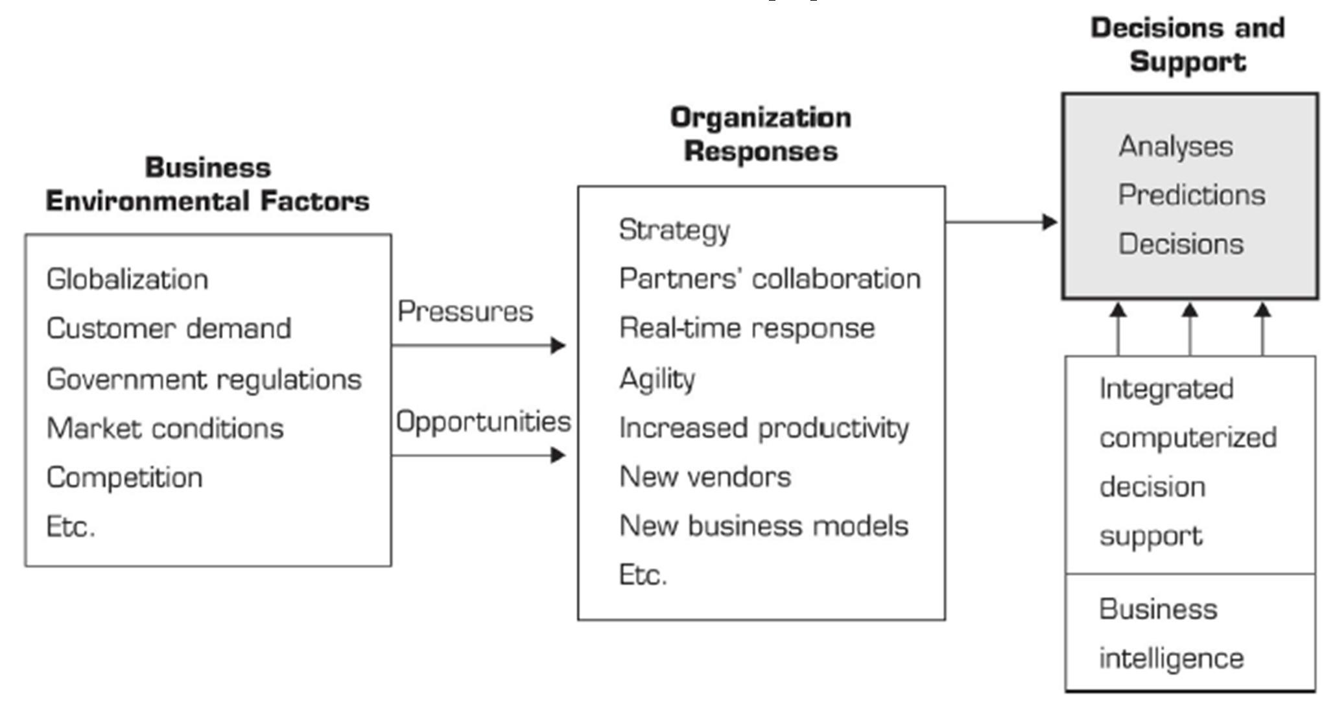

VARIOUS TOOLS AND TECHNIQUES THAT MAY BE

INCLUDED IN A BI SYSTEM

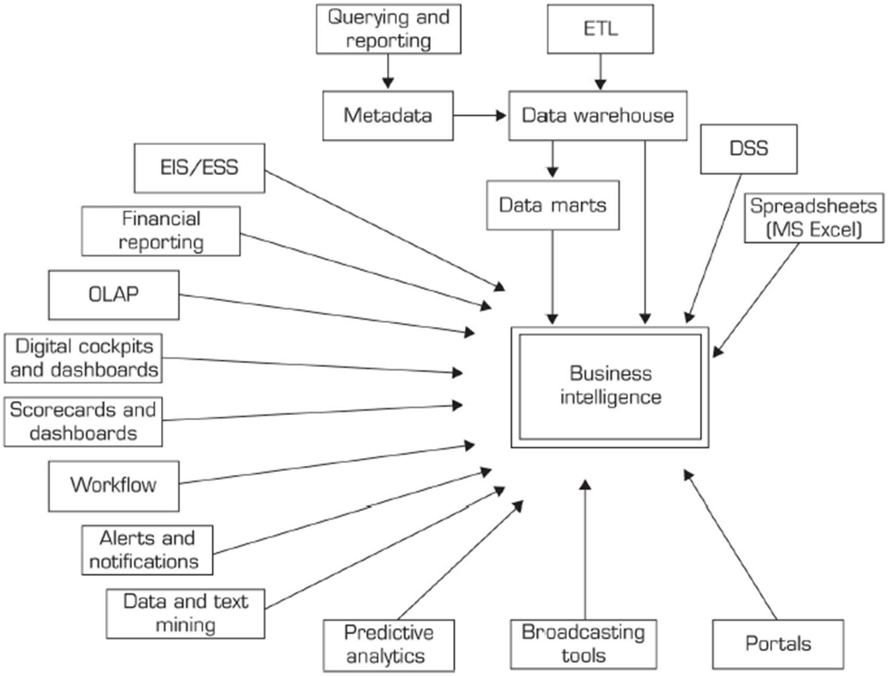

**Advantages of Business Intelligence**

Here are some of the advantages of using Business Intelligence System:

**1. Boost productivity**

With a BI program, It is possible for businesses to create reports with a single click thus saves lots of time and resources. It also allows employees to be more productive on their tasks.

**2. To improve visibility**

BI also helps to improve the visibility of these processes and make it possible to identify any areas which need attention.

**3. Fix Accountability**

BI system assigns accountability in the organization as there must be someone who should own accountability and ownership for the organization’s performance against its set goals.

**4. It gives a bird’s eye view:**

BI system also helps organizations as decision makers get an overall bird’s eye view through typical BI features like dashboards and scorecards.

**5. It streamlines business processes:**

BI takes out all complexity associated with business processes. It also automates analytics by offering predictive analysis, computer modeling, benchmarking and other methodologies.

**6. It allows for easy analytics.**

BI software has democratized its usage, allowing even nontechnical or non-analysts users to collect and process data quickly. This also allows putting the power of analytics from the hand’s many people.

**BI System Disadvantages**

**1. Cost:**

Business intelligence can prove costly for small as well as for medium-sized enterprises. The use of such type of system may be expensive for routine business transactions.

**2. Complexity:**

Another drawback of BI is its complexity in implementation of datawarehouse. It can be so complex that it can make business techniques rigid to deal with.

**3. Limited use**

Like all improved technologies, BI was first established keeping in consideration the buying competence of rich firms. Therefore, BI system is yet not affordable for many small and medium size companies.

**4. Time Consuming Implementation**

It takes almost one and half year for data warehousing system to be completely implemented. Therefore, it is a time-consuming process.

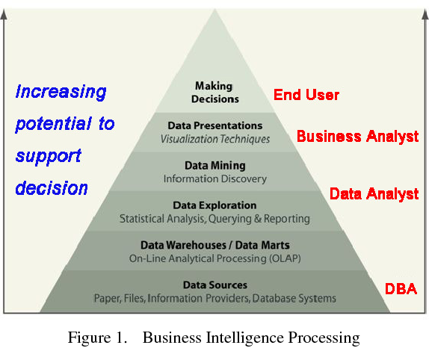

**The BI Process**

Although business intelligence is utilized in different ways and for different purposes by individual companies, the process is fairly uniform throughout all industries and typically unfolds as follows:

* Data from various sources — including internal company data and external market data — is collected, integrated, and then stored; because “big data” is commonly used, data is commonly stored in what’s called a data warehouse, created by a data engineer
* Data sets are created and prepared for data analysis, often by creating data analysis models
* Data analysts run queries against the data sets or models
* The results of queries are used to produce visualizations in the form of charts, graphs, histograms, or other visual representations, along with BI dashboards and reports
* Decision-makers utilize the data visualizations and reports to help them in making decisions; they may also use their BI dashboard to probe further into the data for more information.

**public intelligence and private intelligence.**

, the public intelligence as gathering of information for interest of regional and local government, and states that public intelligence is more complex than private intelligence in the respect that the goals of businesses are clearer. It is also classified Further public intelligence in to three categories: local, regional, and national. On the other hand, that the private intelligence includes business and nonprofit-organizations intelligence. The author notes that it is important to pay attention, since business intelligence has two meanings. At the very end of the chapter, the author shows the differences between private and public intelligence and customer relation management, as well as the differences between private and public intelligence and knowledge management.

PPI process is primarily based on obtaining and gathering information. There are many means of collecting information, based on the three main types of sources: (1) information obtained directly from people, (2) information obtained from traces of human actions, and (3) information obtained from nature interaction

**The strategies** used for gathering public and private business information, are ruled by laws and regulations, which may be difficult to be aware of when operating internationally. However, it can be solved by the socialization process. The four main strategies of information gathering are: (1) defensive strategy, (2) offensive strategy, (3) ethical offensive, and (4) ethical defensive.

**the differences between data, information and intelligence**, by explaining their interrelations in the process towards intelligence. Nowadays, in the information era, the companies gain competitive advantage by efficient and effective handling and managing information. Additionally, the author mentions the information asymmetry as a source of competitive advantage, which is described as a possession of valuable information in comparison to the competitors.

The technology of intelligence

The use of sophisticated technology for information gathering has been developed rapidly since the Second World War, all through the Cold War. Information gathering through the use of technology is divided into several areas, including signal intelligence (SINGINT), which includes electronic interception and cryptanalysis, and consists of communication intelligence (Comint). Then we have imagery/photo intelligence (Imint/Photint), which is intelligence from photographic and other image sources. There is also a radar intelligence (Radint), radars used for gathering information, and acoustic intelligence (Acoustint/Acint), the tracking and identification from underwater sound. Finally, there is also an electrical intelligence (Elint)

the biggest source of non-technological intelligence gathering (Human intelligence –HUMINT)

**competitive advantage** : Sustainable competitive advantage is achieved when a firm receives a return of investment that is greater than the industry norm and that persists for a period long enough to alter the nature of industrial competition or the relative strength of the organization, despite market entry and rivals’ attempts at replication

1. What is Business Intelligence (BI)?
2. Define Business Intelligence. Give some examples.
3. Briefly discuss history of Business Intelligent.
4. Define business intelligence and explain its process
5. What is the purpose of business intelligence systems?
6. What are the strategies used for gathering information
7. What are the key advantages of business intelligence system?
8. Write the brief description of Business Intelligence Applications.

Why business intelligence is important

Business intelligence gives organizations the ability to ask questions in plain language and get answers they can understand. Instead of using best guesses, they can base decisions on what their business data is telling them — whether it relates to production, supply chain, customers or market trends.

Why are sales dropping in this region? Where do we have excess inventory? What are customers saying on social media? BI helps answer these critical questions.

“Business intelligence provides past and current insights into the business,” This is achieved through an array of technologies and practices, from analytics and reporting to data mining and predictive analytics. By providing an accurate picture of the business at a specific point in time, BI provides an organization with the means to design a business strategy based on factual data.”

Business intelligence helps organizations become data-driven enterprises, improve performance and gain competitive advantage. They can:

* Improve ROI by understanding the business and intelligently allocating resources to meet strategic objectives.
* Unravel customer behavior, preferences and trends, and use the insights to better target prospects or tailor products to changing market needs.
* Monitor business operations and fix or make improvements on an ongoing basis, fueled by data insights.
* Improve [supply chain management](https://www.ibm.com/topics/supply-chain-management) by monitoring activity up and down the line and communicating results with partners and suppliers.

Retailers, for example, can increase cost savings by comparing performance and benchmarks across stores, channels and regions. And, with visibility into the claims process, insurers can see where they are missing service targets and use that information to improve outcomes.